**Mapping Micro-Level Electoral Trends: A Decadal Analysis of Booth-Level Voter Shifts**

**Anisha Dey**, B.Sc (Hons) Statistics, 2024-2028, St. Xavier’s College, Kolkata

**Aritra Pahari**, B.Sc (Hons) Statistics, 2024-2028, St. Xavier’s College, Kolkata

**Noel Emmanuel,** B.Sc (Hons) Statistics, 2024-2028, St. Xavier’s College, Kolkata

**Sayak De,** B.Sc (Hons) Statistics, 2024-2028, St. Xavier’s College, Kolkata

**Songbortika Ghosh,** B.Sc (Hons/Research) Economics, 2024-2028, Amity University, Kolkata

**Sujon Majhi**, B.Tech (Information Technology), 2022-2026 Government College of Engineering & Ceramic Technology

Project Guide Name: **Aparna Bhattacharya**

Period of Internship: **19th May 2025 - 15th July 2025**

Report submitted to: **IDEAS – Institute of Data Engineering, Analytics and Science Foundation, ISI Kolkata**

1. **Abstract:**

This research examines the political party trend over the last ten years to seek pattern shifts in the voting behaviour of voters from 2014 to 2024. It relies on long-term data, a classification system, to evaluate shifts in party dominance at every polling booth over time with longitudinal data and visual techniques. Voting participation ranges are grouped from A to D, and the findings are presented in the form of line charts. These graphics identify the stability of the strongholds and the emergence of swing booth changes and give insights that are commonly lost in higher-level analysis of the electoral cycle. In addition to voting behaviour, the study includes demographic data, age, and gender, to understand the effect of socio-political factors on voting decisions. It examines important demographic-party appeal relations with scatter plots and correlation matrices. Lastly, this technique enhances understanding of local political change while giving strategists appropriate resources for precision-targeted electoral participation.

1. **Introduction:**

Modern-day democracy is being shaped more and more by national, regional, and local factors in its election results. Conventional analysis ignores infinitesimal differences in the interest of capturing large tendencies. During 2014-2024, we fill this gap by a close booth-level analysis of West Bengal's voting loyalties. We examine the patterns of voting percentage change with actual voting figures of Sample District-Trend and Sample District-Profile and detect regions of stability and volatility.

Advanced Excel formulas like FILTER, INDEX, and MATCH were utilized in data summary and organizing statistics. Python automated data analysis, producing trend line charts and correlation coefficients for party performance and demographic trends. Correlation heatmaps and scatter plots analysed voter demographics and election outcomes, and determined significant patterns and trends.

Our training comprised important technologies for this research, including data science, Python, Power BI, no-code ML platforms, generative AI, LLMs, statistics, and analytics. It enhanced our technical data analysis and visualization skills, and the project was successful. This research incorporates these tools for a strong analysis of election trends and an implementable model of political landscapes.

1. **Project Objective:**

* **Data Collection:**  Our mentor gave us decadal election data to ascertain accuracy in voter leanings and party performance.
* **Data Filtering and Categorization:** Excel 'FILTER' function was utilized to filter and categorize data according to grades (A, B, C, D) based on threshold values. Later on, a Python script evaluated the performance of each booth.
* **Grade Assessment:** Excel’s "INDEX, MODE, MATCH" functions determined the most common grade for every political entity in a decade.
* **Decadal Performance Analysis**: Examining the performance of parties X, Y, and Z in the past decade showed notable vote share trends and swings.
* **Yearly Decomposition of Performance:** Line graphs and scatter plots indicated trends in vote percentages at booths. Decomposition by year provides insight into dynamics over time.
* **Statistical Analysis and Correlation:** Python and Excel were employed in conducting correlation matrices to analyse the correlations between demographic variables (age, gender) and party performance, allowing for a better understanding of the influence of socio-political variables on voting behaviour.
* **Strategy Formulation:** Based on analysis of performance, the election strategy for each party will be developed. This will inform campaign strategies by identifying prominent booths and communities to win elections in the future.

1. **Methodology:**
2. **Data Collection:**  Our mentor gave us access to the real Trend and Profile data.
3. **Data Pre-processing and Cleaning:**  We performed data cleaning after acquiring the data to make it accurate. It entailed:  
   a) Eliminating entries that were redundant or unnecessary.

b) Resolving incomplete rows or adding missing data.

c) Converting data types to provide correct numerical formatting.

1. **Data Grading and Classification**: The data was classified into four groups according to party vote share: A (more than 35%), B (25% to 35%), C (15% to 24%), and D (less than 15%). This classification enabled us to follow the parties' performance over time. In Excel, we applied functions like "FILTER," "IF," "MATCH," and "INDEX" to classify the vote shares.
2. **Data Visualisation and Analysis:** Data was analysed with the following methods:
3. Data processing and visualization were carried out in Python with the assistance of libraries such as pandas for data processing and Matplotlib for plots.

* ***Dashboard for Electoral Analysis using Streamlit:***

Codes for interactive Streamlit dashboards and booth-level analysis can be found at:

<https://github.com/kuhu2505/IDEAS-TIH-ISI-PROJECT-Group-14-/blob/main/ISI.ipynb>

1. We developed an interactive electoral dashboard using Streamlit to analyse voting patterns across constituencies. Key features include **interactive filters** for party and constituency selection, **line charts** for vote trends**, histograms** for vote distribution, **automatic winner identification by year**, and **access to raw data for transparency**. The dashboard highlights **party dominance, voter volatility**, and **complements statistical analyses through dynamic visual exploration**. Hosted on Streamlit Cloud at:

<https://kuhu2505-ideas-tih-isi-project-group-14--isi-2-sjvxmk.streamlit.app/>

1. An interactive Streamlit dashboard plots election trends at the booth level from constituencies. Demographic and party data are utilized to generate **correlation heatmaps, volatility analysis, and 2D/3D scatter plots of party preference against age and gender.** *The constituencies and variables can be selected by users through an easy-to-use sidebar.* The tool offers **micro-level political analysis from statistical analysis and real-time data exploration.** It's deployed on Streamlit Cloud and backed by version-controlled source files on GitHub at: <https://pujdrrkat4bctnf3gwzw7v.streamlit.app/>
2. **Correlation Analysis**: Correlation function within the "Data Analysis" tool provided correlations between demographic variables (such as gender, age) and percentages of votes, providing insights into trends in voter behaviour.
3. **Booth Categorization and Data Interpretation**: The booths were categorized based on performance following an analysis.
4. Strong: Where the party had high vote percentages.
5. Swing Booths: Voting shares had dramatic swings over the years.
6. Declining/Recovering: Booths with associated declines or recoveries in performance.

VI. **Developing Strategy:** Electoral strategies specific to important booths and segments were developed through performance tracking, in consonance with volatility patterns and party patterns.

1. **Data Analysis and Results:**

We first deal with the Trend data, which is followed by the Profile data.

**Constituency 4 (AC-4)**



*In the Excel sheets provided below, the numerical data spanning from Party Z-24 to Party W-14 has been systematically categorized into four distinct groups labelled A, B, C, and D.*

**Report of Party-Z (AC-4):**



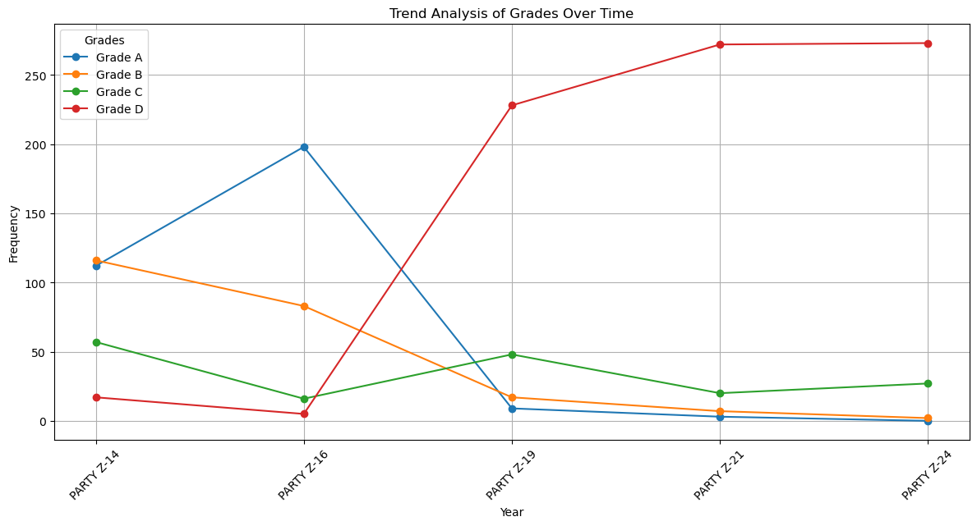

**Electoral Performance Dashboard: Party Z (Z-14 to Z-24)**

|  |  |
| --- | --- |
| **Metric** | **Analysis** |
| Z-14 | * Strong rise in Grades A & B (~115). * Minor C/D share. * Best phase for the party. |
| Z-16 | * Grade A peaks performance (~200). * Significant decline in B, C, & D (~85, 15, 8); indicating consolidation. |
| Z-19 | * Opposition dominates - catastrophic drop in Grades A and B (~12,18). * Grade D surges (~230), and Grade C also increases (~48). |
| Z-21 | * Continued deterioration; Grade D (~270) peaked. * Minor presence of others. * The party becomes heavily underperforming. |
| Z-24 | * Persistent weakness; Grade D dominance is sustained (~270). * C slightly improved (from 22 to 30). * A & B became virtually negligible. * The party remains in a prolonged weak state. |

* **Classification:** *Declining* (Although Excel identifies 'Swing' as the most frequent category for each booth, the overall performance trend is declining.)
* **Strategy:**

1. Micro-level recovery at Grade C & D booths.
2. Overhauling Ground Network
3. Reorganize leadership, appoint on merit.

* **Conclusion:** Party Z’s strength has evaporated; voter apathy is near total.

**Report of Party-Y (AC-4):**



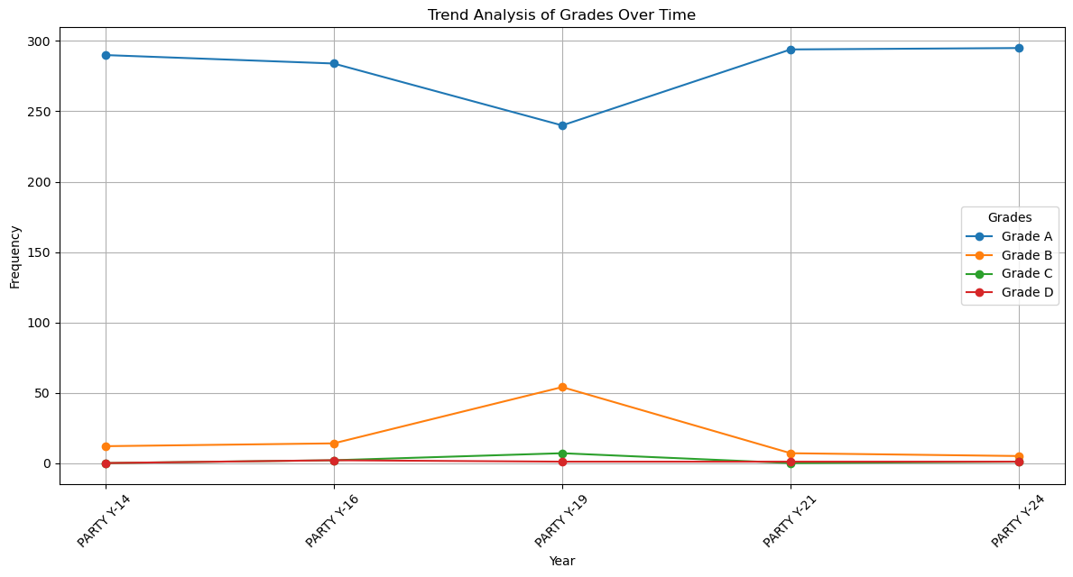

**Electoral Performance Dashboard: Party Y (Y-14 to Y-24)**

|  |  |
| --- | --- |
| **Metric** | **Graph-Based Analysis** |
| Y-14 | |  | | --- | |  |  |  | | --- | | * Grade A dominates (~290). | |
| Y-16 | * Dominance persisted. * Minor increase in B/C, but primarily Grade A (~285). |
| Y-19 | * Temporary disruption recognised for Grade A (~decreasing from 285 to 240). * Grade B spike (~from 15 to 55) exhibits weakening. |
| Y-21 | * Grade A rebounds immediately peaking (~292), whereas other grades drop drastically again. |
| Y-24 | * Consistently strong performance sustained; minimal opposition. |

* **Classification: *Consistently Strong***
* **Strategy**: To sustain Grade A momentum.
* **Conclusion**: Volatility is negligible, and throughout, strength is retained.

**Report of Party-X (AC-4):**



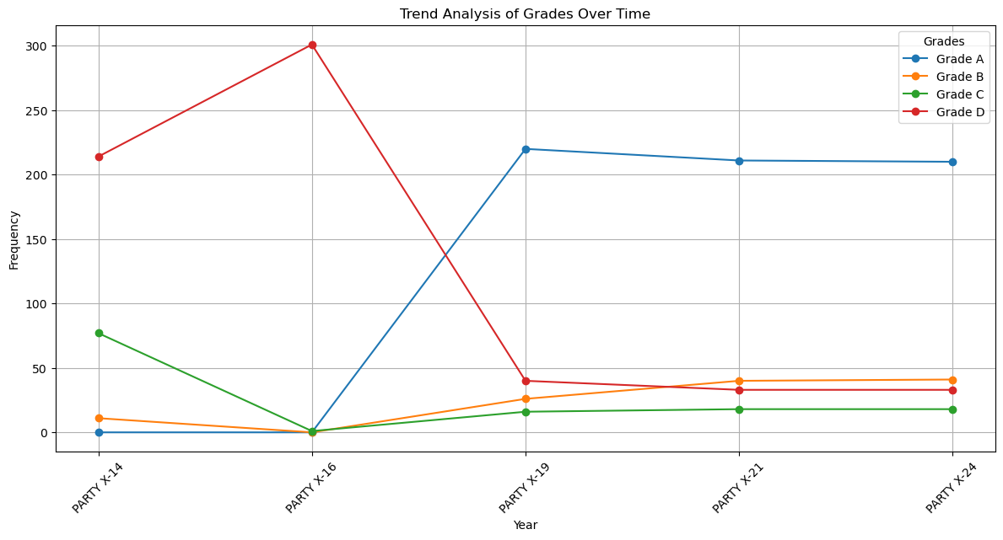

**Dashboard of Electoral Performance: Party X (X-14 to X-24)**

|  |  |
| --- | --- |
| **Metric** | **Evaluation** |
| X-14 | |  | | --- | |  |  |  | | --- | | * Heavily eroded. * Grade D (~215) dominates, with very low Grade A presence. | |
| X-16 | * Performance declined from weak to collapsed. * Grade D hits peak (~300), near-zero scores elsewhere. |
| X-19 | * Dramatic turnaround—Grade A leapfrogs from negligible to 220. |
| X-21 | * Stability pertains. * Grade A’s stronghold is sustained, slight rise in B/C/D. |
| X-24 | * Plateau is maintained; performance holds steady, and no major shifts are observed. |

* **Classification**: *Recovering*
* **Strategy:**

1. Targeted retention of Grade A is sustained by deepening voter engagement in stronghold booths post-2019.
2. Reconverting pockets still showing Grade B/C/D via localized messaging and welfare visibility.
3. Institutionalizing early warning systems to avoid any relapse like the 2014–2016 deterioration.

* **Conclusion:** From collapse to sustainability, Party X exhibits a remarkable structural recovery.

**Constituency 6 (AC-6)**



**Report of Party Z (AC-6)**



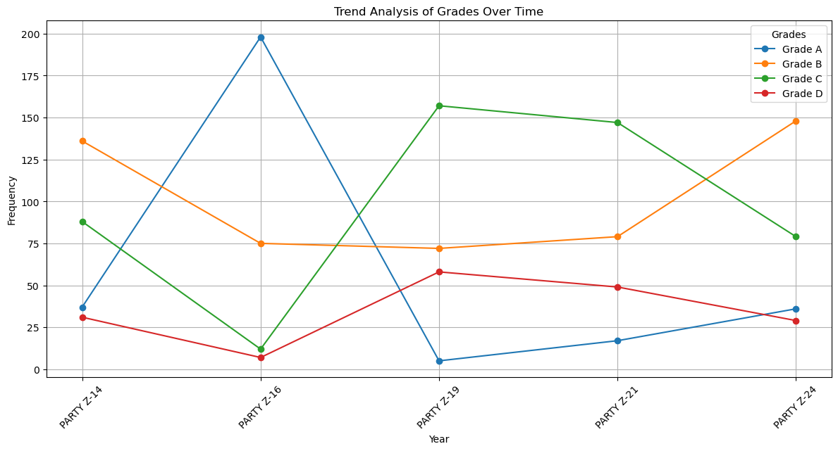

**Electoral Performance Dashboard: Party Z (Z-14 to Z-24):**

|  |  |
| --- | --- |
| **Metric** | **Analysis** |
| Z-14 | * Grade B dominates (~135). * C performs moderately (90). |
| Z-19 | * Surge in Grade A (~200), indicating strong consolidation. |
| Z-16 | |  | | --- | |  |  |  | | --- | | * Crash of Grade A (~10). * Grade C becomes dominant (~160). * Volatile year. | |
| Z-21 | * The picture remains identical to 2016. |
| Z-24 | |  | | --- | |  |  |  | | --- | | * Shift back to Grade B dominance (~148). * Slight recovery of A. | |

* **Classification:** *Swing / Volatile*
* **Strategies:**

1. Maintaining constituency outreach and pre-empting disillusionment.
2. Grade C areas need issue-based micro-campaigns.
3. Strengthening organizational depth to convert runner-up regions into winning seats.

* **Conclusion:** Party Z reflects volatility masked as competitiveness.

**Report of Party-Y (AC-6)**



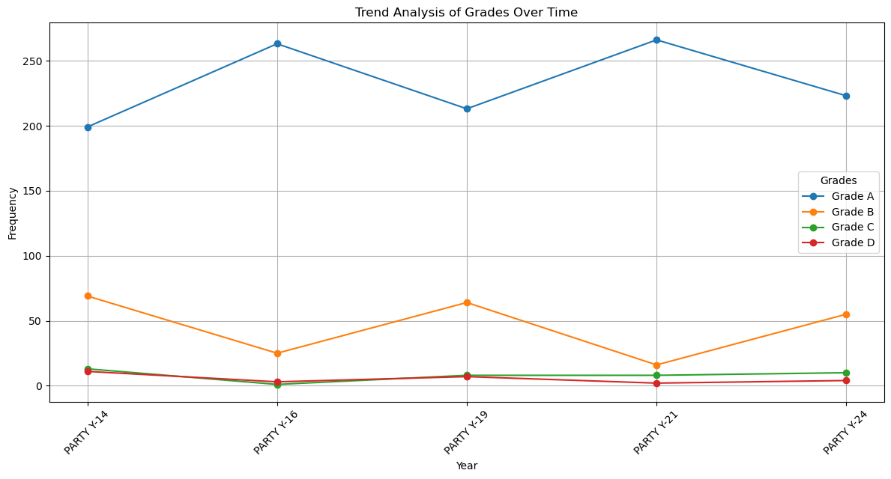

**Electoral Performance Dashboard: Party Y (Y-14 to Y-24):**

|  |  |
| --- | --- |
| **Metric** | **Analysis** |
| Y-14 | * Strong mandate (High grade A:200) with controlled opposition and low fragmentation. |
| Y-16 | * Zenith of dominance (Grade A peaked: 265). * Dip in other grades (Grade B reduced from 70 to 28). * Portraying a hallmark of electoral support. |
| Y-19 | * Maintains dominance. * Marginal reactivation of competition (increase in grade B: 65, marginal rise in grade D – from 2 to 9) * However, grade A: 215 is not threatened. |
| Y-21 | * Restored full dominance after a minor slip. |
| Y-24 | * Retains the top position (stable high of grade A: 225) with signs of increased competition (moderate nature of grade B: 55) * Grades C & D are irrelevant, suggesting that fragmentation and electoral failure are not a concern for Party Y. |

* **Classification:** *Consistently Strong*
* **Strategies:**

1. Investing in young people's participation and online engagement to be competitive.
2. Exhibiting leadership by technology, openness, and community involvement.
3. Identifying regions with rising runner-up votes and reinforcing presence.

* **Conclusion:** Temporary dips in dominance need to be watched out for. Long-term dominance necessitates strategic retooling.

**Report of Party-X (AC-6)**



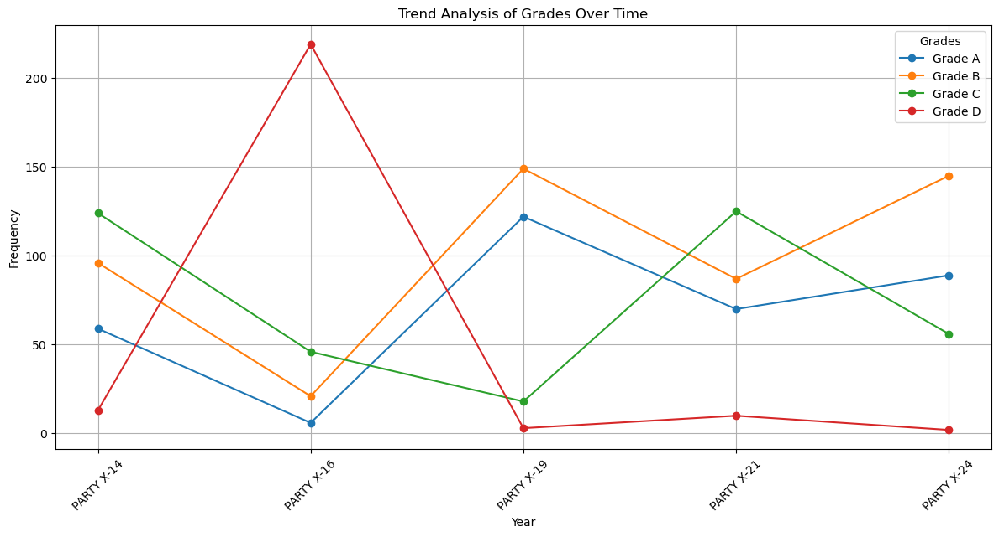

**Electoral Performance Dashboard: Party X (X-14 to X-24):**

|  |  |
| --- | --- |
| **Metric** | **Analysis** |
| X-14 | * Fragmented but competitive. * Strong B (~95) and C (~125) performance. |
| X-16 | * Total breakdown: landslide defeat, near irrelevance |
| X-19 | * Dramatic comeback. * Grade A (Strong ~125) and B (Peaks ~150) surge. * Minimal existence of lower grades. |
| X-21 | * Fragmentation returns. * A weakens (Declines ~ 70), C resurges again (~125). |
| X-24 | * Stabilizing trend. * Mild rise in grade A (~90), and strong grade B (~145). * Strong runner-up status re-established. |

* **Classification:***Swing / Volatile*
* **Strategies:**

1. Securing Grade B regions and converting them into Grade A constituencies.
2. Addressing causes of Grade C volatility; unify factions or forge strategic coalitions.
3. Strengthening crisis management and voter engagement to avoid repeats of the X-16 collapse.

* **Conclusion:** It portrays extreme volatility marked by sharp collapses and recoveries, with no sustained grade dominance across years.

**Constituency 12 (AC-12)**



**Report of Party Z (AC-12)**



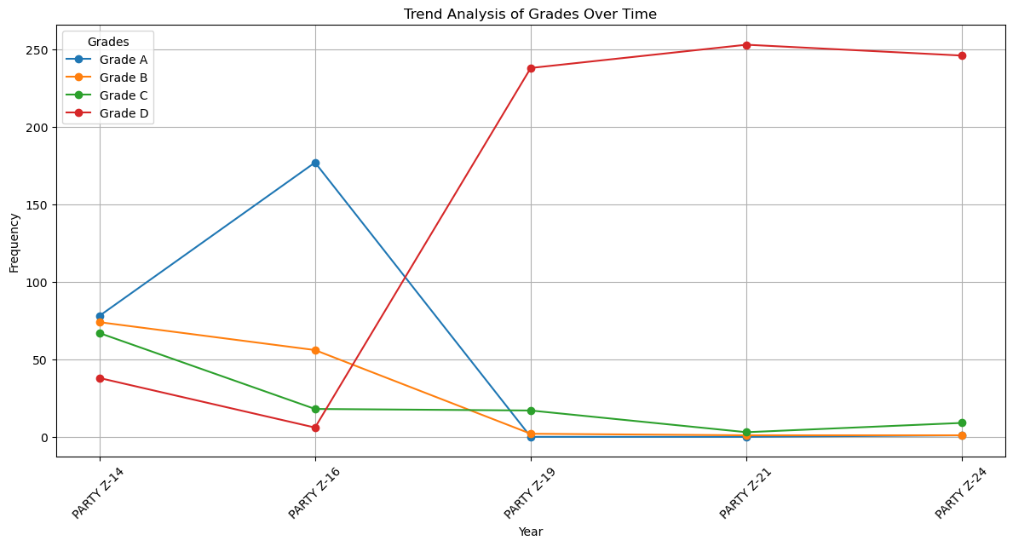

**Electoral Performance Dashboard: Party Z (Z-14 to Z-24):**

|  |  |
| --- | --- |
| **Metric** | **Analysis** |
| Z-14 | * Balanced performance. * Competitive in A/B, but fragmented. |
| Z-16 | * Apex of electoral strength (Grade A: 178). |
| Z-19 | * Catastrophic reversal: total voter disengagement from Z. * Grade A collapses and grade D peaks. |
| Z-21 | * Prolonged collapse, nearly complete voter withdrawal from mainstream grades. |
| Z-24 | * Z remains in deep electoral irrelevance. |

* **Classification:** *Declining* (Although Excel identifies 'Swing' as the most frequent category for each booth, the overall performance trend is declining.)
* **Strategies:**

1. Restoring ideological clarity and field links by door-to-door contact.
2. Bringing forth a new generation of credible, dynamic leaders.
3. Moving from defense to courageous, relevant proposals.

* **Conclusion:**  Party Z falls precipitously from dominance to decline, with Grade D dominating after 2019.

**Report of Party Y (AC-12)**



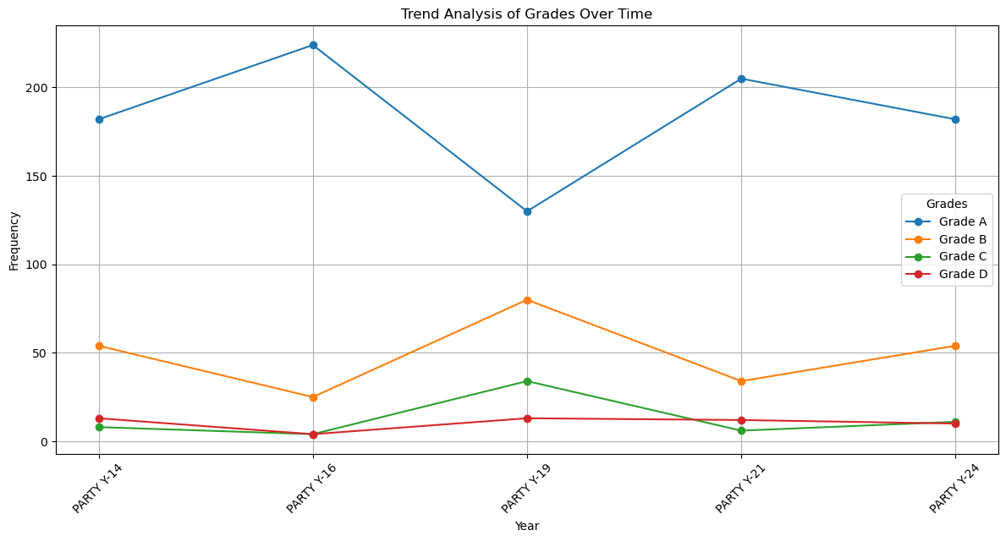

**Electoral Performance Dashboard: Party Y (Y-14 to Y-24):**

|  |  |
| --- | --- |
| **Metric** | **Analysis** |
| Y-14 | * Solid leadership (Grade:180) with manageable opposition and minor fragmentation. |
| Y-16 | * High point of dominance (Grade A peaks: 225) and consolidation. |
| Y-19 | * Significant dip in dominance (Grade A: 130). * Fragmentation and runner-up strength increase (Grade B decreases from 27 to 80). |
| Y-21 | * Recovery of command, though slight resistance and discontent remain. (Grade A rebounds to 205). |
| Y-24 | * Competitive stability: Grade B resurging (from 35 to 55) while Grade A experiences mild decline (from 205 to 180). |

* **Classification**: *Swing*
* **Strategy:**

1. Reinforcing strongholds during downturns to prevent Grade B encroachment.
2. Investigating reasons behind Grade C/D rises in Y-19 and Y-24.
3. Counter any coalitional or regional growth reflected in Grade B surges.

* **Conclusion:**

Party Y maintains Grade A dominance with minor mid-cycle dips, reflecting overall stability with brief volatility.

**Report of X:**



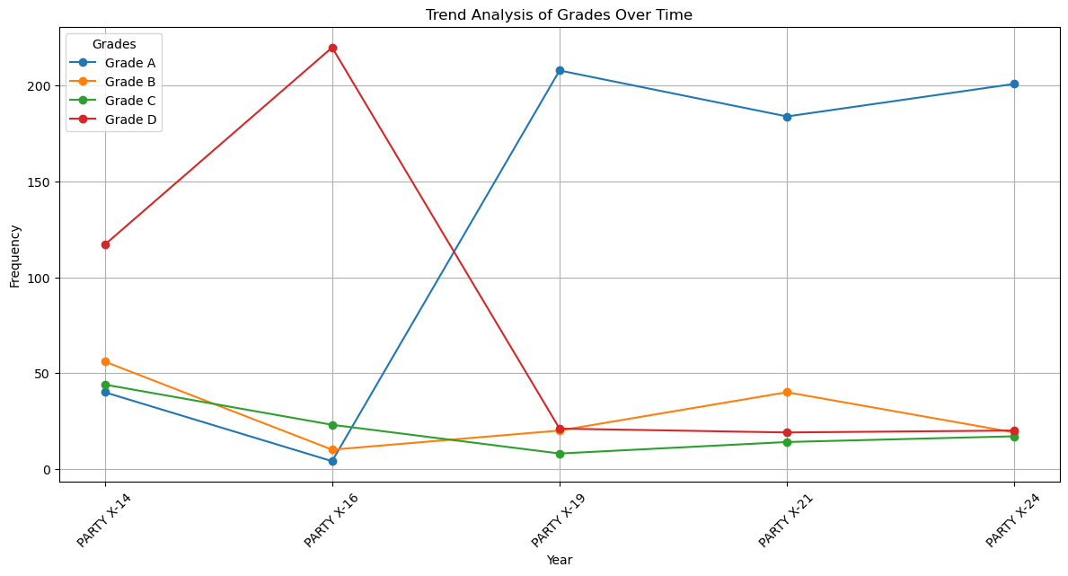

**Electoral Performance Dashboard: Party X (X-14 to X-24):**

|  |  |
| --- | --- |
| **Metric** | **Analysis** |
| X-14 | * Fragmented profile with notable discontent (Grade D dominance (~120)) |
| X-16 | * Electoral breakdown — widespread rejection reflected in Grade D (~220) and Grade A declined from a poor performance of 40 to 8. |
| X-19 | * Stunning comeback — landslide revival of dominance. * Resurgence of Grade A (210). |
| X-21 | * Stability returns (Grade A: 185) — credible runner-up pressure builds (Grades B and C have a slight increase). |
| X-24 | * Consolidated hold (Grade: 200), though fragmentation shows early signs of re-emergence. |

* **Classification**: *Recovering*
* **Strategies:**

1. To continue grassroots connections and high-visibility governance following the X-19 resurgence.
2. Addressing growing Grade C signs in X-24 suggests early disenchantment.
3. Guarding vulnerable regions indicated by Grade B growth in X-21.

* **Conclusion:** Party X transitioned from early instability and collapse to a sustained phase of Grade A consolidation, reflecting strategic recovery and structural realignment.

**Comparative Trends Across Constituencies**

**PARTY Z**

* Sharp Decline in performance.
* Grade Polarization indicates a collapse of dominance and a rise in lower-tier grades, suggesting preference deterioration.

**PARTY Y**

* Consistent Electoral Excellence is portrayed by Grade A remaining dominant and stable, with minimal fluctuations. Grade D stayed negligibly low.

**PARTY X**

* Fluctuating yet having a balance can be observed from the Grades, which show sharp volatility—Grade A and B alternate in dominance; Grade D spikes sporadically (notably in X-2016).
* Mixed Trends suggests inconsistency in quality but not a systemic decline.

**Conclusion**

Party Y leads in electoral consistency, Party Z suffers a dramatic fall, while Party X shows fitful volatility.

**Constituency 4 (AC-4)**



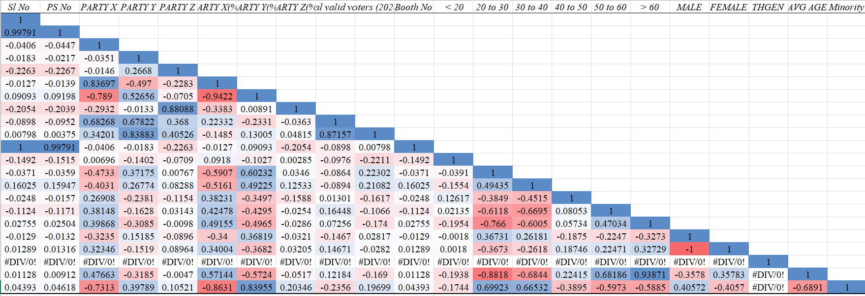

**Electoral Performance Dashboard: Party X (X-14 to X-24):**

|  |  |  |  |  |
| --- | --- | --- | --- | --- |
| **Demographic Group** | **PARTY X** | **PARTY Y** | **PARTY Z** | **Key Interpretation** |
| < 20 | -0.14016 | -0.0918 | 0.08086 | * Low overall interest. * Slight bias towards Z. |
| 20 to 30 | -0.47332 | 0.60232 | -0.08636 | * Strong support for Y. * Consistent with progressive agendas. * Rejects X. * They could potentially be against conventional platforms. |
| 30 to 40 | -0.40307 | 0.49225 | -0.08944 | * Moderate support for Y. * Disinterest in X. |
| 40 to 50 | -0.27126 | 0.1253 | 0.07656 | * Support for Y fades. * Slight rise for Z. * X begins to gain. * This may hint at the start of a realignment stage. |
| 50 to 60 | 0.38188 | -0.42595 | -0.17408 | * A shift towards X. * Grows an aversion to Y. * Some preference for stability. * Z’s disinterest intensifies. |
| > 60 | 0.39856 | -0.49646 | -0.13086 | * Strongest support for X. * Highest aversion to Y. * Shows a strong conservative base of the elderly. |

|  |  |  |  |  |
| --- | --- | --- | --- | --- |
| **Gender** | **PARTY X** | **PARTY Y** | **PARTY Z** | **Key Insight** |
| Male | -0.32346 | 0.36819 | -0.14671 | * Favors Y. * Consistent with reformist views. * Opposes X. * Portrays aversion to conservatism. |
| Female | 0.3204 | -0.36819 | 0.14671 | * Favors X & Z. * Against Y. * Shows some gendered polarization, and women may refer to accounts that remain status quo. |

**Key Takeaways:**

* A Clear ideological transition from progressive (Party Y) to conservative (Party X) is clear from 20 to > 60.
* WFFWTMen progressively favour Y, while women favour X/nationalist (Z).
* Party Z having a dismal presence in most ages/genders suggests it is a minor/regionally limited force.

**Constituency 6 (AC-6)**



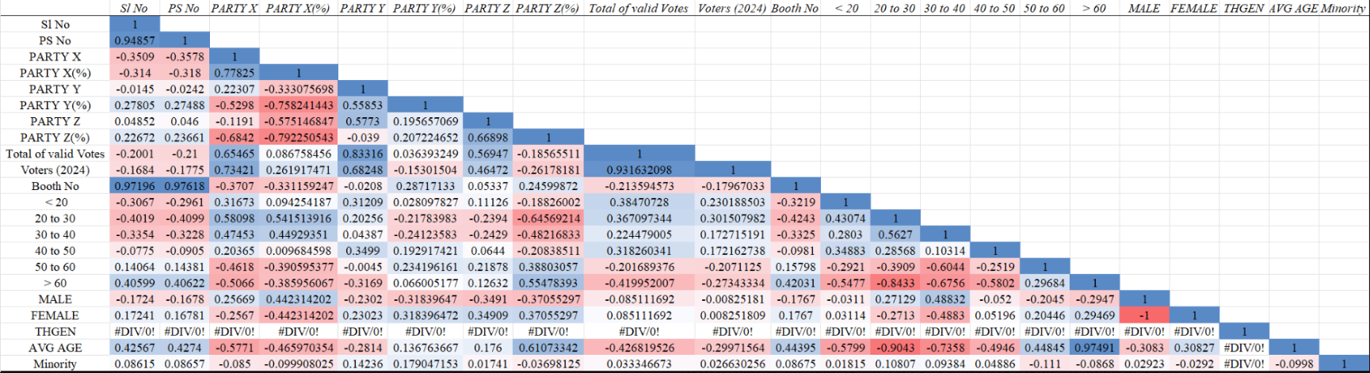

|  |  |  |  |  |
| --- | --- | --- | --- | --- |
| **Demographic Group** | **PARTY X** | **PARTY Y** | **PARTY Z** | **Key Interpretation** |
| **< 20** | 0.32 | 0.31 | -0.19 | * Low interest in all. * Slight youth preference for X & Y. * Z fails to attract first-time voters. |
| **20 to 30** | 0.58 | 0.20 | -0.24 | * Strong support for X. * Moderate interest in Y. * Clear rejection for Z. * Indicates progressivist leanings. |
| **30 to 40** | 0.47 | 0.04 | -0.24 | * Mild support for X. * Y’s popularity declines. * Z remains unfavourable. * Suggests voter bloc transitions. |
| **40 to 50** | 0.20 | 0.35 | 0.06 | * Y has no significant increase. * Somewhat stronger Z support. * Stagnating support for X. * Realignment demographics. |
| **50 to 60** | -0.46 | -0.00 | 0.22 | * X's support declines. * Indifference towards Y. * Z’s support increases. * Returning to conservative tendencies. |
| **> 60** | -0.51 | -0.32 | 0.55 | * Z’s Strongest support. * Reject X and Y. * Conservative base. * Dedicated older voters. |

|  |  |  |  |  |
| --- | --- | --- | --- | --- |
| **Gender** | **PARTY X** | **PARTY Y** | **PARTY Z** | **Explanation** |
| **Male** | 0.26 | -0.23 | -0.35 | * Favors X. * Resists Y. * Z is extremely unpopular. * Indicates modernist and nationalist sentiments. |
| **Female** | -0.26 | 0.23 | 0.35 | * Favors Y and Z. * Opposes X. * Emerging gendered divergence. * Traditional and welfare party preference. |

**Key Takeaways:**

* Party X leads among men and youths, with a modern appeal.
* Party Y enjoys average support from middle-aged and female voters but no robust support.
* Party Z enjoys a female and older voter base, which reflects a conservative constituency.



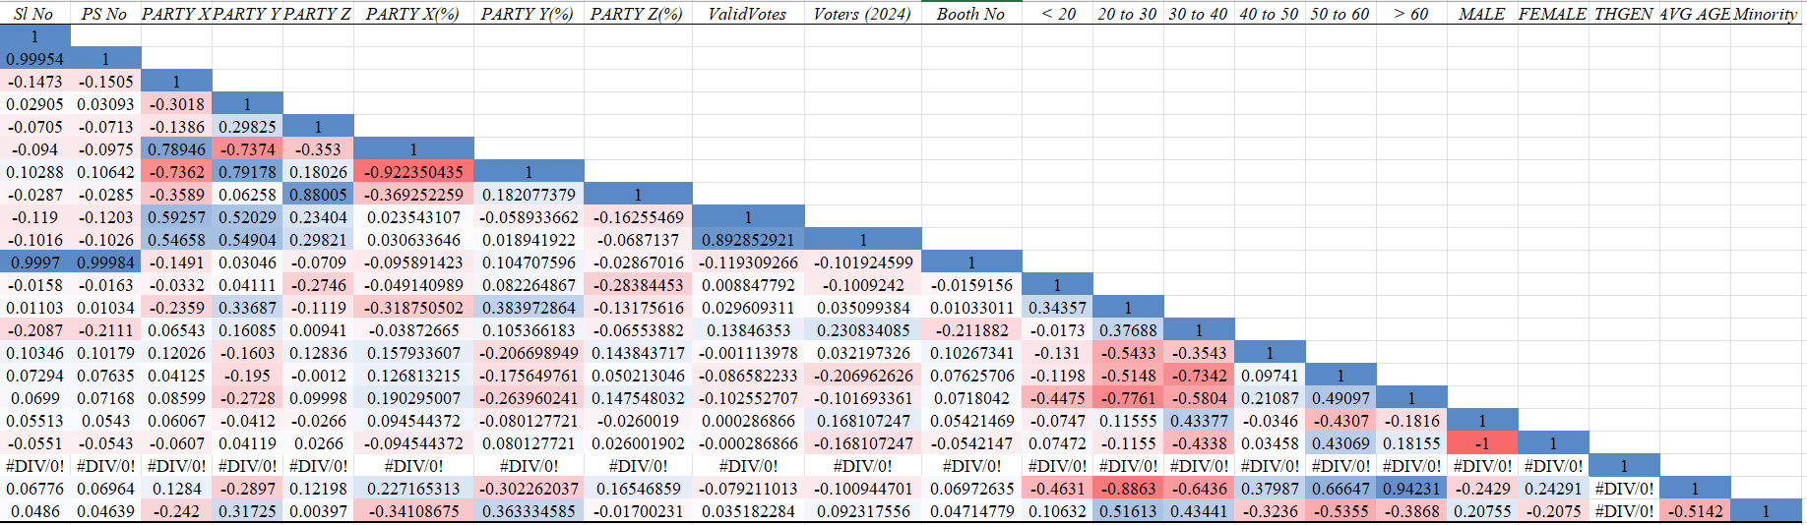

|  |  |  |  |  |
| --- | --- | --- | --- | --- |
| **Demographic Group** | **PARTY X** | **PARTY Y** | **PARTY Z** | **Key Insight** |
| **< 20** | -0.0332 | 0.0411 | -0.2746 | * Weak interest overall. * Minor Y tilt. * Z is unpopular. |
| **20 to 30** | -0.2359 | 0.3369 | -0.1120 | * Strongest support for Y. * X and Z rejected. * Indicates reformist leanings. |
| **30 to 40** | 0.0654 | 0.1608 | 0.0094 | * Mild leaning towards Y. * X and Z gain minimal traction. |
| **40 to 50** | 0.1203 | -0.1603 | 0.1284 | * X and Z start to rise. * Y’s assistance fails. * Indicates ideological change. |
| **50 to 60** | 0.0412 | -0.1950 | -0.0012 | * X constant, Y keeps decreasing. * Z stagnates. |
| **> 60** | 0.0860 | -0.2728 | 0.0999 | * The elderly prefer more toward Z and X. * Y is the least favoured. |

|  |  |  |  |  |
| --- | --- | --- | --- | --- |
| **Gender** | **PARTY X** | **PARTY Y** | **PARTY Z** | **Explanation** |
| **Male** | 0.0607 | -0.0412 | -0.0266 | * Mild male preference for X. * Moderate total enthusiasm. |
| **Female** | -0.0607 | 0.0412 | 0.0266 | * Mirror of male pattern. * Slight inclination toward Y and Z. * No overarching preference. |

**Key Takeaways:**

* Party Y is supported by young voters, especially the 20–30 age group.
* The older voters like Party Z a bit more and accept X moderately.
* There are few gender differences, with slight X (male) and Y/Z (female) preferences.

1. **Conclusion:**  
   This project provides an analysis of ten years of election dynamics, setting out key trends in party and demographic performance. Employing advanced statistics and graphics, it offers insight into party and voter behaviour with a view to more informed grassroots activity.
2. **Appendix:**

* The following link guides to the sources used for the research of this thesis.

[](References.zip)

* Codes for interactive Streamlit dashboards and booth-level analysis can be found at:

<https://github.com/kuhu2505/IDEAS-TIH-ISI-PROJECT-Group-14-/blob/main/ISI.ipynb>

* The interactive dashboard for Trend data, representing line graphs, histograms, winner party, and raw data, is available at: <https://kuhu2505-ideas-tih-isi-project-group-14--isi-2-sjvxmk.streamlit.app/>
* The interactive dashboard for Profile data, showing volatility analysis, correlation heatmap, and 2D/3D scatter plots of party preference against age and gender at: <https://pujdrrkat4bctnf3gwzw7v.streamlit.app/>